**1**.**Create a bucket in IBM object storage.**

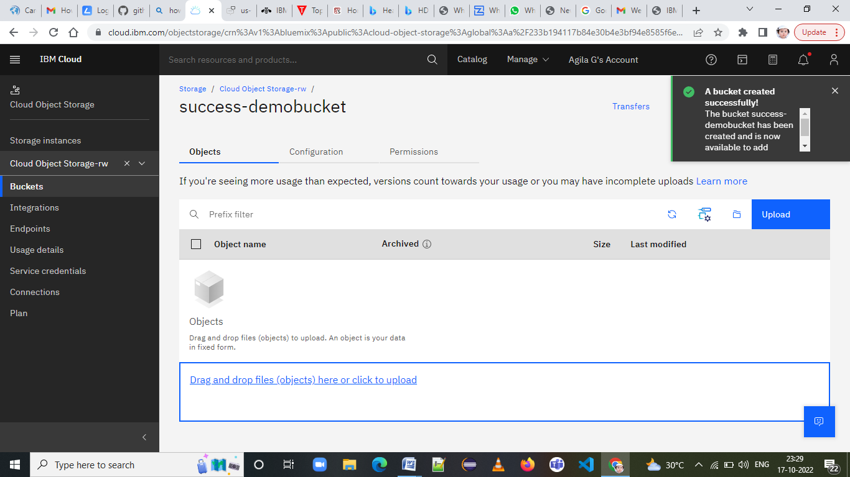

**2.Upload an 5 images to ibm object storage and make it public. write html code to displaying all the 5 images.**

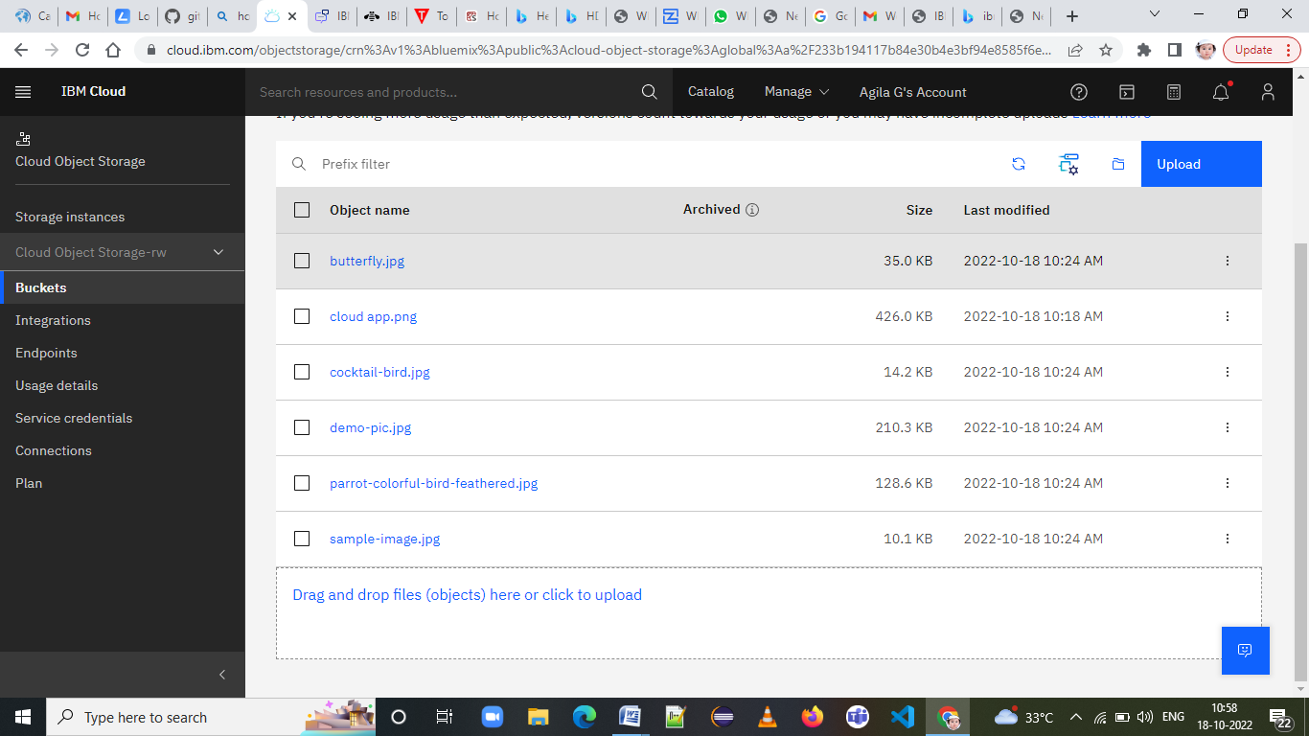

**<html>**

**<head>**

**<title>Displaying images</title>**

**</head>**

**<body><b>**

**<h1>**

**cloud object storage</h1></b><center>**

**<img src="C:\Users\THENMOZHI\Documents\Agila\butterfly.jpg" alt="butterfly.jpg" width="500" height="600">**

**<img src="C:\Users\THENMOZHI\Documents\Agila\cocktail-bird.jpg">**

**<br>**

**<br>**

**<img src="C:\Users\THENMOZHI\Documents\Agila\cloud-app.png" width="400" height="200"></center>**

**<b>**

**<h1>**

**cloud Application Development</h1></b>**

**<center>**

**<img src="C:\Users\THENMOZHI\Documents\Agila\demo-pic.jpg" width="400" height="200">**

**<br>**

**<br>**

**<img src="C:\Users\THENMOZHI\Documents\Agila\parrot-colourful-bird-feathered.jpg">**

**</center>**

**</body>**

**</html>**

**3. Upload a css page to the object storage and use the same page in your HTML code.**

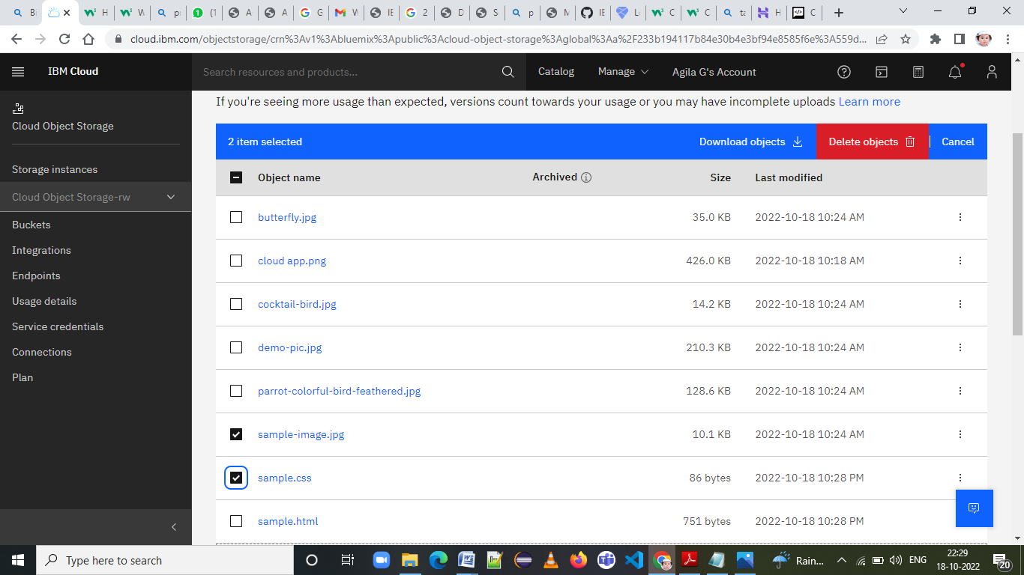

**4.Design a chatbot using IBM Watson assistant for hospital. Ex: User comes with query to know the branches for that hospital in your city. Submit the web URL of that chat bot as a assignment.**

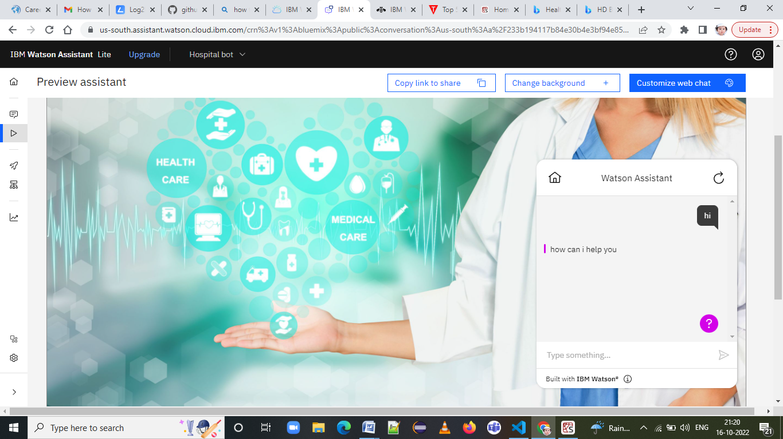

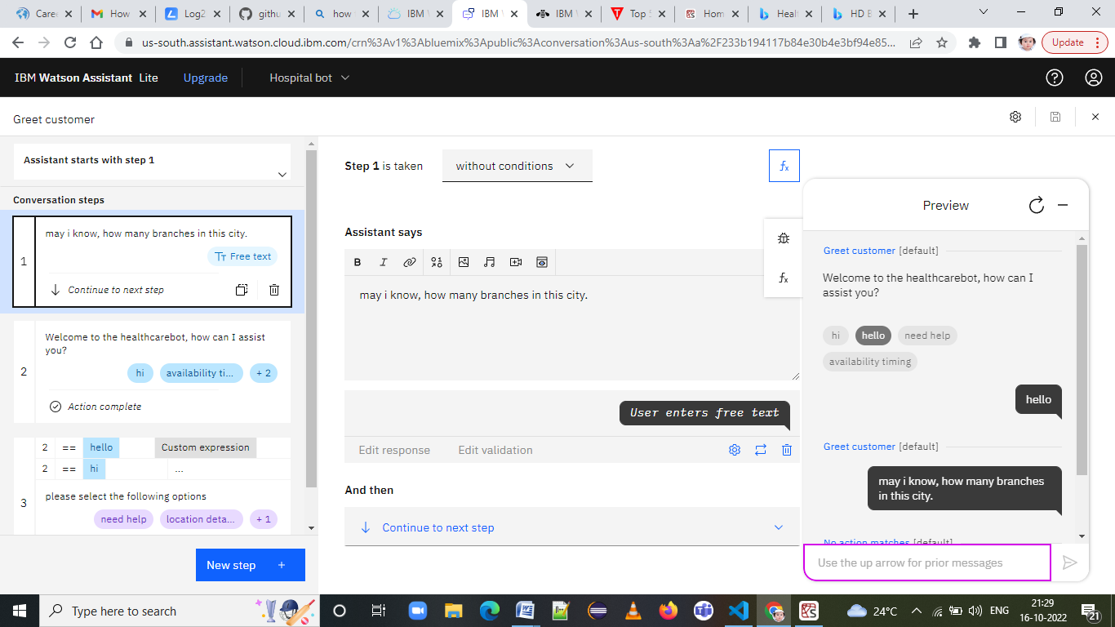

https://web-chat.global.assistant.watson.appdomain.cloud/preview.html?backgroundImageURL=https%3A%2F%2Fus-south.assistant.watson.cloud.ibm.com%2Fpublic%2Fimages%2Fupx-4401c5cb-2f4d-4861-8ceb-1e0c73744e25%3A%3A6897e36d-f1b8-40e7-817f-82f01d4d67a1&integrationID=a26b44c1-3573-4672-85ae-3412773603b0&region=us-south&serviceInstanceID=4401c5cb-2f4d-4861-8ceb-1e0c73744e25

**5.Create Watson assistant service with 10 steps and use 3 conditions in it. Load that script in HTML page.**

